Cyclic Redundancy Check (CRC) - Part 1

Divisor will be decided between the sender and the receiver.

CRC Generation at sender side

1. Find the length of the divisor L
2. Append L-1 bits to the original message
3. Perform binary division operation
4. Remainder of the division = CRC
5. Note: the CRC must be of L-1 bits.
6. XOR operation:
   1. 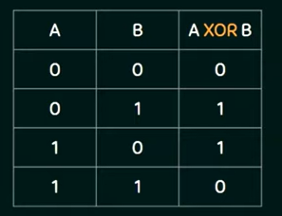
7. 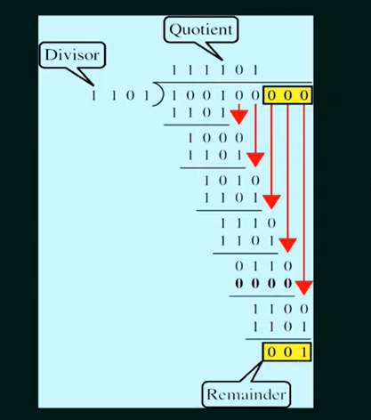
8. 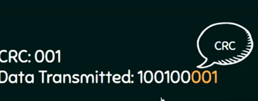
9. 